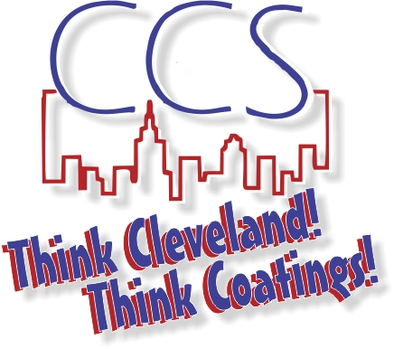
CCS SCHOLARSHIP OPERATION PROCEDURES
The following is a guideline for administrating the Cleveland Coatings Scholarship awards. It explains the responsibility of
TIME | TASKS | RESPONSIBLE
July | Appoint and/or confirm the Scholarship Committee chairs. | CCS President and CCS board
Sept-Oct | Update the next years Scholarship Guidelines and Scholarship Application. Make any needed changes and add the new deadline for the following year. | Scholarship Committee
Nov | Post the new scholarship documents to the CCS web page. | CCS Administrator
Nov-Feb | Announce to membership that the new Scholarship Applications are posted and are now being accepted. | CCS President, Board and Administrator
March | Forward all Scholarship Applications to the Scholarship Committee. | CCS Administrator
March | Review and score the scholarship applications and make recommendations to the CCS Board. | Scholarship Committee
March | CCS Board reviews the scholarship recommendations and makes a final determination on the awards. | CCS President and CCS board
April | Scholarship spreadsheet is updated with the recipients and award amounts. | CCS Administrator
Apr-May | Recipients are contacted and invited to the designated award dinner. | Scholarship Committee
July | Scholarship Payment Request letter is emailed to all students and their parents to notify them the procedure to request payment. | CCS Administrator
Jul – Aug | Review 2nd, 3rd, 4th year awardees eligibility regarding members meeting attendance and 3.0 GPA compliance. Consult scholarship committee with questions. | CCS Administrator
July-Sept | Payments are sent to the respective Bursars office and the Scholarship tracking spreadsheet is updated. After all payments are completed, post the updated scholarship spreadsheet. | CCS Administrator

